Self-checks are very important in identifying who has possible symptoms of Covid-19 infection, as this helps reduce those with the infection attending football activity and transmitting the infection to others. This quick check should be done before each training session so those who trigger a positive answer, can stay away to protect everyone else.

We request that each participant undertakes the following self-screen check list before travelling to a training session or other football activity. If you answer ‘yes’ to any one of them you should not travel to the session and follow all applicable Government Guidance. It is important to remember some people can pass on the virus before they develop symptoms, or never have symptoms despite being infectious. Despite everyone’s best efforts, these cannot be screened out of training.

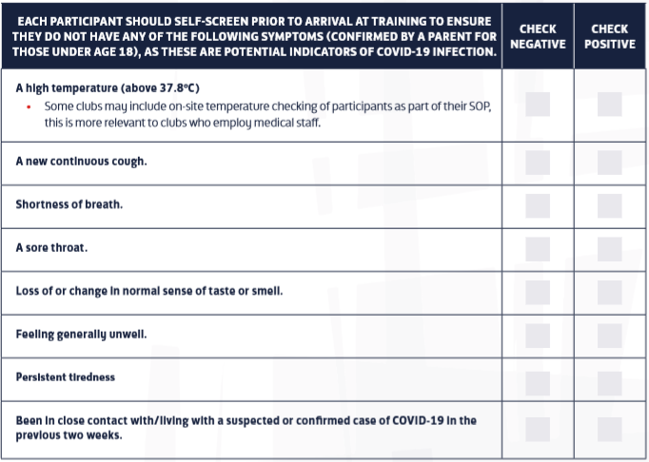
It is important to remember some people can pass on the virus before they develop symptoms, or never have symptoms despite being infectious. Despite everyone’s best efforts, these cannot be screened out of training. If a player is showing symptoms of the virus as above, or has been in contact/living in a household with someone displaying symptoms, or had a positive test result within the last two weeks, then they should stay at home until a NHS practitioner advises them they no longer need to remain in isolation8. Any player who has had Covid-19 symptoms should be cleared by their own doctor before returning to training. As an absolute minimum those players who have had symptoms lasting more than seven days during their illness, even if asymptomatic at the time of returning to football, should have full medical clearance before returning to training9. If symptoms resume, or players feel unwell or have persistent tiredness on return to training they should consult their own doctor again.

