We look forward to welcoming you to the home of Northallerton Town Juniors in the next few days and hope you have a safe and enjoyable day.

The following information will help you to plan your journey. Please share all this information with your team members and supporters.

If you’re using any form of Sat Nav, our postcode is DL7 8HJ and we are on Ainderby Road, Romanby, Northallerton.

Our pitches are next to Northallerton Town Football Club and all cars are to be parked in the car park at Northallerton Town Football Club. Please be considerate to our neighbours and do not park on the roadside, verges or in the park. Please do not block the pedestrian entrance from the car park into the park.

Dogs are NOT allowed in either the Park or at the Football Club.

Covid – 19

You will be aware of the Covid 19 health and hygiene regulations we are required to implement. Please ensure anyone travelling to Northallerton is aware of the following.

Everyone in your party should self-assess for COVID-19 symptoms before travelling. If anyone is symptomatic or living in a household with possible or actual COVID-19 infection they should not attend. We ask all visitors to bring their own hand sanitiser for during the match and to adhere to the current Government guidance on social distancing when standing with other spectators.

We have four new QR code signs situated around the club with three on Ainderby Park site and one on the back pitch at Northallerton Town FC. These are to be used by all that participate, coach and spectate at games. We have also installed four hand sanitiser stations near to the QR codes.

You are still required to complete the Track and Trace register below. This must be completed and returned to the Northallerton coach organising your fixture in advance of the game. The game will not commence until the Covid Register of the visiting team is completed.

Players should arrive in kit as our changing rooms and toilets will be closed.
During the game itself, we welcome the applauding of good play by both sides but ask that you support our stance of insisting that spectators, coaches and players refrain from foul and/or aggressive language or actions. Anyone doing so will be asked to leave our land. In light of Covid we ask you please to avoid shouting.

Please ensure that all visitors, whether players, coaches or spectators, are aware of, and agree to abide by, the FA Respect Code. This is a condition of entry to our facilities. All of our matches see FA Respect barriers in place and we ask that all spectators stand behind these. We also ask that all visitors and coaches remain in their assigned areas and within their social bubbles. We request coaches do not walk up and down the touchline. If anyone is unsure of where to stand please ask any club official.

We wish you an enjoyable day at Northallerton Town Juniors.

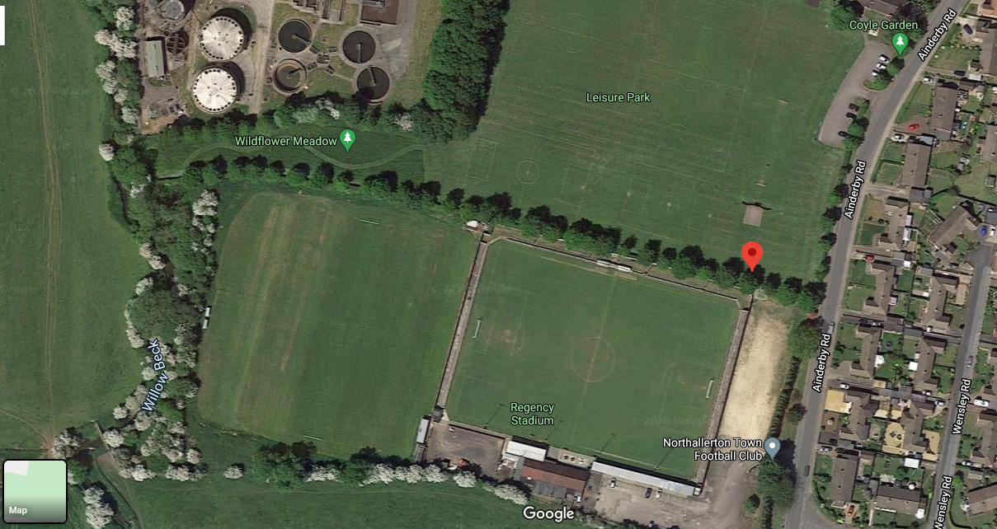

Car Parking for Football

Pedestrian Access

Emergency Vehicle Access only

VISITING COACH: PLEASE COMPLETE AND RETURN THE COVID TRACK AND TRACE REGISTER BELOW.

NORTHALLERTON TOWN JUNIORS FC COVID COMPLIANCY REGISTER

NTJFC v…..….. …………………………………………………………

Date ……………..………………………………………….KO Time………………… Age………………

Visiting Team Coach/Contact Number………………..…………………………………………………………….

Players Name | Number of Additional Visitors

