Welcome back to the 2020/21 season at Northallerton Town Juniors FC. This letter is just a reminder of information and details about attending matches and training at Northallerton Town Juniors FC.
IMPORTANT
Before attending our football club, or travelling to an away club, EVERYONE must undergo a self-assessment for any Covid-19 symptoms.
No-one should leave home if they, or someone they live with, has any of the following symptoms:
• A high temperature (above 37.8C)
• A new, continuous cough
• A loss of, or change to, their sense of smell or taste.
If, during a match, anyone in attendance becomes symptomatic they should leave and return home IMMEDIATELY. They should then contact the NHS.
We have four QR code signs situated around the club with three on Ainderby Park site and one on the back pitch at Northallerton Town FC. These are to be used by all that participate, coach and spectate at games.
Please can everyone ensure that they still use NHS Covid 19 Track and Trace app and check-in every time you bring your child/children to a training session or a game. We will still be maintaining a register of all those who attend as we are aware some people are unable to download the NHS app. All registers will be kept for 21 days and the details will only be passed to NHS Track & Trace if requested.

On match days we will have four hand sanitiser stations near to the QR codes.

TEAM COVID
We still need everyone’s help to be able to continue playing in a safe environment. We need volunteers from every team to assist their coach on a match day with Covid duties. These duties include cleaning flagpoles, goal posts and balls before, during and at the end of the game, implementing & monitoring social distancing around your pitch and completing the attendance register for your team. This help will allow coaches to continue managing the team.

We may also need help marshalling people at the gate from the car park onto the park, we appreciate that everyone has come to enjoy the football and we don’t want anyone to miss their game but we need everyone to understand these actions have to be taken to ensure the safety of everyone attending NTJFC. Please let your coach know if you are happy to help.
The following guidance is for ALL players, coaches, club officials, match officials, league officials, volunteers, parents/ carers and spectators.
We expect everyone to follow the following simple steps:
• Be Responsible. Read the guidance provided by the FA, your club, the opposition club and the league. This will allow you to be familiar with any changes to the game and expectations of you.
• Practice Good Hygiene. You should use hand sanitiser regularly but in particular before, during and after a game. NTJFC players will be asked to use hand sanitiser before the match.
• Maintain Social Distancing. This will not be possible for players and referees in a competitive match, however social distancing should be adhered to before and after a match or whilst on the side-lines (for example substitutes). There should be no pre- or post- match handshakes. All Northallerton Town Junior Football Club Covid-19 Match Day Policy spectators are expected to stand in bubbles of no more than 6 people, each bubble should be 2m from the next. Home and away fans MUST stand apart from each other and coaches are not permitted to walk up and down the touchline. Under current FA guidance NO spectators are allowed at grassroots football, one parent or carer per child is permitted.
• Support NHS Test and Trace. Everyone attending a match at our grounds will be entered onto a Covid Register. This will ensure that, in the event of a Covid-19 case, those potentially infected can be traced. Information will be kept for 21 days.
• Strict No Spitting Rule. This includes swilling/ rinsing of the mouth and spitting.
• No Shouting. Players should avoid shouting when face to face with another player/ referee. Spectators should also avoid shouting.
FACILITIES
Currently our changing rooms are closed but our toilets will be open.
KICK OFF
Times maybe staggered throughout the day and your team’s normal kick off time could be changed. This is to ensure social distancing and to keep everyone safe.
EQUIPMENT
It is inevitable that there will be contact of the ball by both teams. To minimise contact we ask that:
- NO spectators handle the ball where possible;
- When the ball goes out of play, the ball should be handled as little as possible (so dribbled with the feet to the position of the throw in);
For younger age groups it is common practice to have several players in goal during the two matches. Previously coaches would swap the GK shirt around, this can no longer happen. Therefore, any extra GK’s will be requested to wear a bib.
- Corner flags and goal posts will be cleaned before and during (half time) the game.
FIRST AID/ INJURIES
Injuries can be a regular occurrence in matches. It is important that a child receives the first aid they require, however this must be done safely. Where a child can be assessed from a distance this would be preferable. Should a child require first aid treatment which requires a level of close contact in this instance we would encourage their parent/carer to deliver basic first aid.
Please be assured no child will be left unattended should a parent/carer not be present.
GENERAL HOUSEKEEPING
- Please make sure all your rubbish is placed in the bin. Please do not leave empty bottles on the ground for someone else to have to pick up, this puts other people at risk.
- NO DOGS are allowed within the Park or Football Club.
- No one is to park in the Car Park at the Park, this is for users of the Play Park only and access for emergency vehicles only. There is plenty of parking at the Football Club.

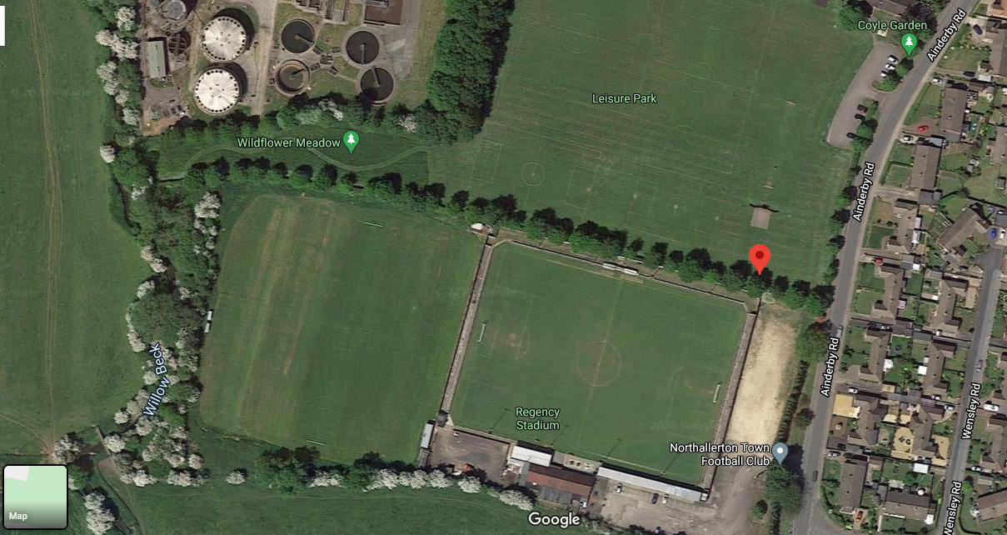

No Parking

Parking

Pedestrian entrance

